# **Apache Solr - Core**

A Solr Core is a running instance of a Lucene index that contains all the Solr configuration files required to use it. We need to create a Solr Core to perform operations like indexing and analyzing.

A Solr application may contain one or multiple cores. If necessary, two cores in a Solr application can communicate with each other.

Creating a Core

After installing and starting Solr, you can connect to the client (web interface) of Solr.

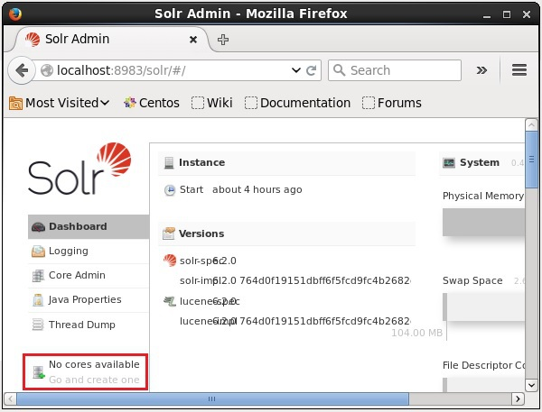

As highlighted in the following screenshot, initially there are no cores in Apache Solr. Now, we will see how to create a core in Solr.

Using create command

One way to create a core is to create a **schema-less core** using the **create** command, as shown below −

[Hadoop@localhost bin]$ solr create -c Solr_sample

Here, we are trying to create a core named **Solr_sample** in Apache Solr. This command creates a core displaying the following message.

Copying configuration to new core instance directory:

/home/Hadoop/Solr/server/Solr/Solr_sample

Creating new core 'Solr_sample' using command:

http://localhost:8983/Solr/admin/cores?action=CREATE&name=Solr_sample&instanceD

ir = Solr_sample {

"responseHeader":{

"status":0,

"QTime":11550

},

"core":"Solr_sample"

}

You can create multiple cores in Solr. On the left-hand side of the Solr Admin, you can see a **core selector** where you can select the newly created core, as shown in the following screenshot.

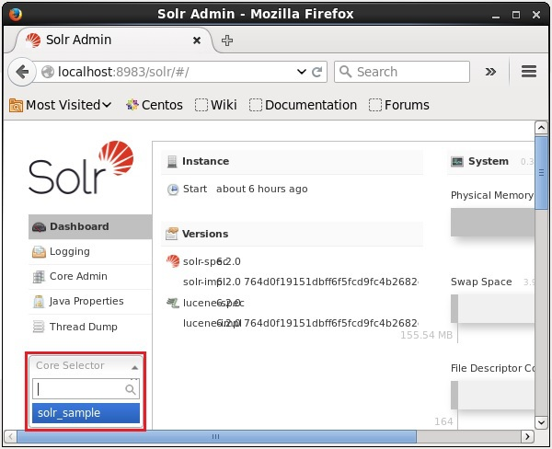

Using create_core command

Alternatively, you can create a core using the **create_core** command. This command has the following options −

|  |  |
| --- | --- |
| –c **core_name** | Name of the core you wanted to create |
| -p **port_name** | Port at which you want to create the core |
| -d **conf_dir** | Configuration directory of the port |

Let’s see how you can use the **create_core** command. Here, we will try to create a core named **my_core**.

[Hadoop@localhost bin]$ solr create_core -c my_core

On executing, the above command creates a core displaying the following message −

Copying configuration to new core instance directory:

/home/Hadoop/Solr/server/Solr/my_core

Creating new core 'my_core' using command:

http://localhost:8983/Solr/admin/cores?action=CREATE&name=my_core&instanceD

ir = my_core {

"responseHeader":{

"status":0,

"QTime":1346

},

"core":"my_core"

}

Deleting a Core

You can delete a core using the **delete** command of Apache Solr. Let’s suppose we have a core named **my_core** in Solr, as shown in the following screenshot.

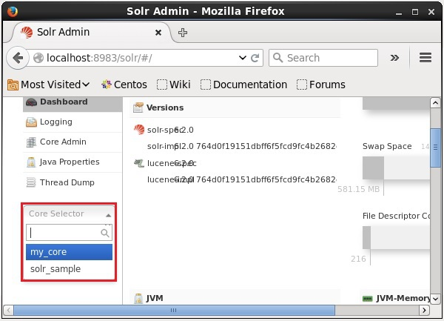

You can delete this core using the **delete** command by passing the name of the core to this command as follows −

[Hadoop@localhost bin]$ solr delete -c my_core

On executing the above command, the specified core will be deleted displaying the following message.

Deleting core 'my_core' using command:

http://localhost:8983/Solr/admin/cores?action=UNLOAD&core = my_core&deleteIndex

= true&deleteDataDir = true&deleteInstanceDir = true {

"responseHeader" :{

"status":0,

"QTime":170

}

}

You can open the web interface of Solr to verify whether the core has been deleted or not.

